SUPPLEMENT
Supplemental Figure 1. Discontinuation rate and time to discontinuation of index biologic during the 12-month follow-up period in patients with psoriatic arthritis who initiated a biologic using a treatment gap cutoff of (A, B) ≥ 45 days and (C, D) ≥ 180 days (sensitivity analysis).*
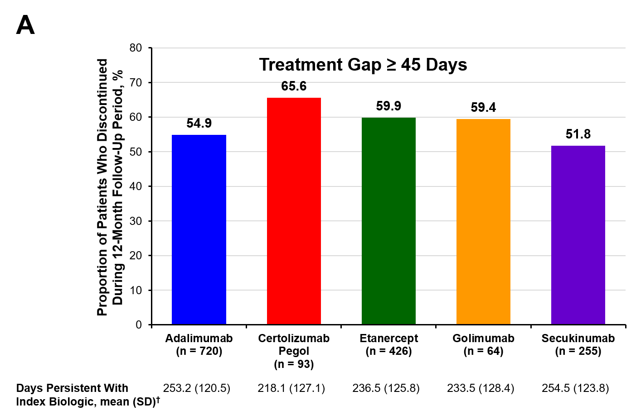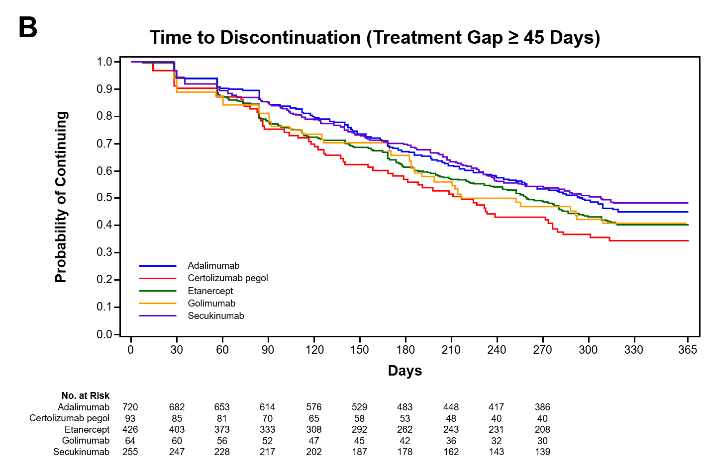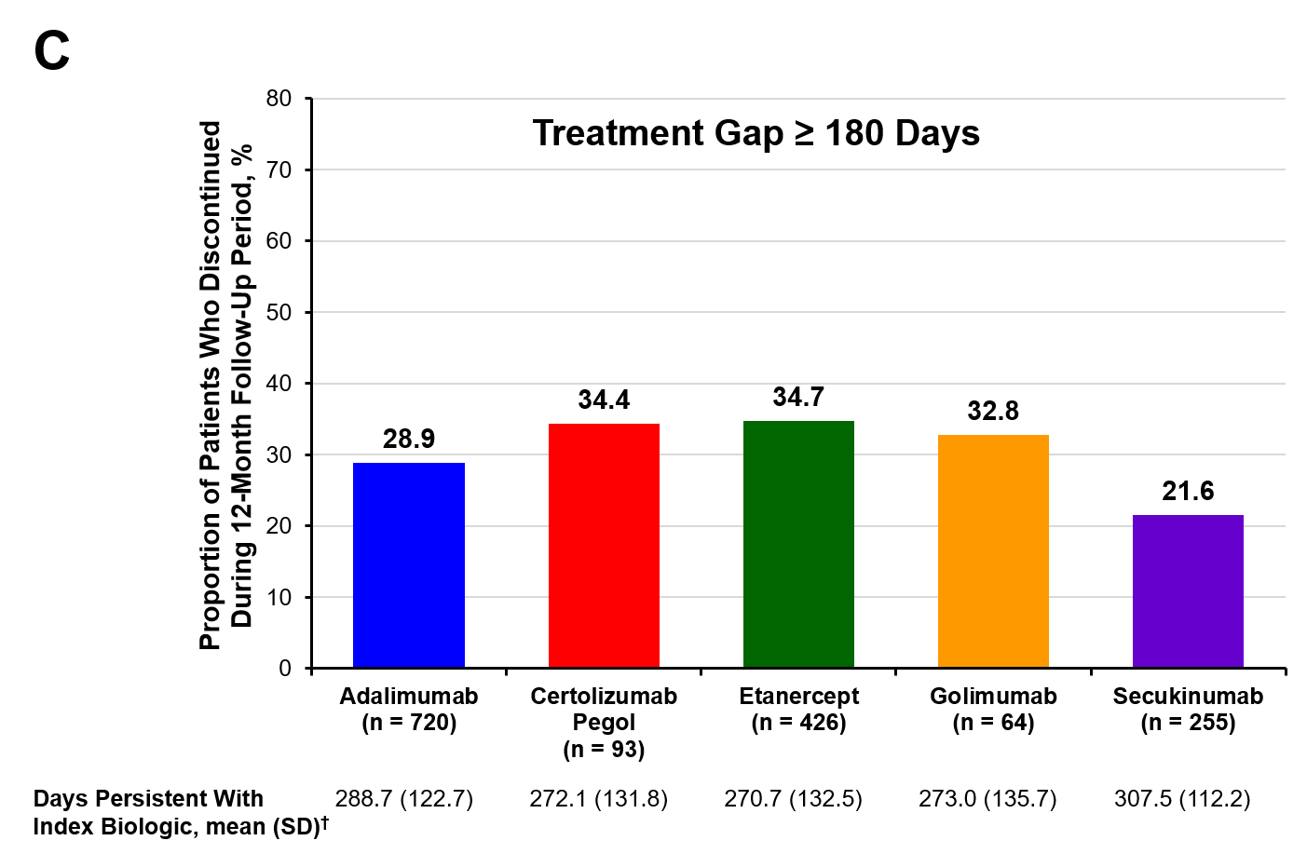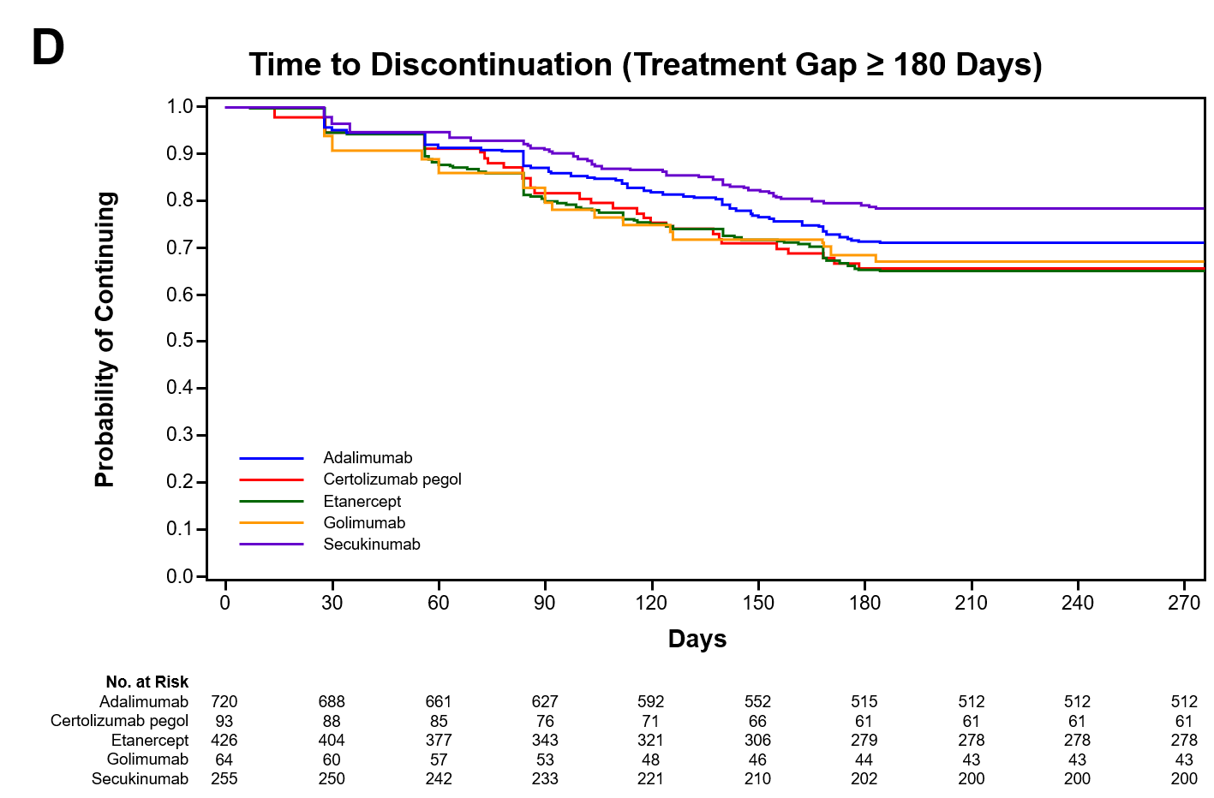
* Discontinuation was defined as no refill of the index biologic within (A, B) 45 days, or (C, D) 180 days after the previous days’ supply was exhausted. † Persistence was defined as the time from the first prescription fill of the index biologic to discontinuation of the index biologic (ie, treatment gap ≥ 45 or 180 days), or the end of follow-up if no gap was observed.

