Appendix A. Coding Algorithms Used For Study Exclusion Criteria, Driver-Specific Events and Construction of Comorbidity Score Measures
Codes Used to Define Exclusion Criteria
Variable |  |  | Codes |  |  |  |  | Code Type
Cardiac Surgery |  |  | 00.5x, 35.xx, 36.xx, 37.xx |  |  |  |  | ICD-9 Procedure
Pericarditis |  |  | 391.x, 393, 420.x, 423.2, 036.41, 074.21, 093.81, 098.83 |  |  |  |  | ICD-9 Diagnosis
Myocarditis |  |  | 391.2, 422.xx, 074.23, 398.0, 429.0, 032.82, 036.43, 093.82, 130.3 |  |  |  |  | ICD-9 Diagnosis
Pulmonary Embolism |  |  | 415.1x |  |  |  |  | ICD-9 Diagnosis
Hyperthyroidism |  |  | 242.x |  |  |  |  | ICD-9 Diagnosis
Valvular heart disease |  |  | 394.0x, 394.2, 396.0, 396.1 |  |  |  |  | ICD-9 Diagnosis
 |  |  | 35.20, 35.22, 35.24, 35.26, 35.28 |  |  |  |  | ICD-9 Procedure
 |  |  | 33999, 0257T, 0258T, 0259T, 33405, 33425, 33426, 33427, 33430, 0262T, 33475, 33460, 33463, 33464, 33465, 33999, 0257T, 0258T, 0259T, 33405, 33425, 33426, 33427, 33430, 0262T, 33475, 33460, 33463, 33464, 33465 |  |  |  |  | CPT
Codes Used to Define Comorbid Conditions of Interest and Disease Scores
Variable |  |  | Codes |  |  |  |  | Code Type
Cancer |  |  | 140.xx-172.xx, 174.xx-208.xx, 230.xx-231.xx, 233.xx-234.xx |  |  |  |  | ICD-9 Diagnosis
Rheumatoid arthritis |  |  | 714.xx |  |  |  |  | ICD-9 Diagnosis
Multiple sclerosis |  |  | 340 |  |  |  |  | ICD-9 Diagnosis
Coronary artery disease |  |  | 411.xx, 412.xx, 413.xx, 414.xx, 429.2 |  |  |  |  | ICD-9 Diagnosis
Acute MI |  |  | 410.xx |  |  |  |  | ICD-9 Diagnosis
Cardiomyopathy |  |  | 425.xx |  |  |  |  | ICD-9 Diagnosis
Ischemic stroke |  |  | 433.x1, 434.x1, 436.x |  |  |  |  | ICD-9 Diagnosis
TIA |  |  | 435.x |  |  |  |  | ICD-9 Diagnosis
Left ventricular heart failure |  |  | 428.1 |  |  |  |  | ICD-9 Diagnosis
Congestive heart failure |  |  | 428.xx |  |  |  |  | ICD-9 Diagnosis
Atrial flutter |  |  | 427.32 |  |  |  |  | ICD-9 Diagnosis
Hypertension |  |  | 401.x, 402.x0, 403.xx, 404.x0, 404.x2, 405.xx |  |  |  |  | ICD-9 Diagnosis
Peripheral artery disease |  |  | 440.xx, 443.xx |  |  |  |  | ICD-9 Diagnosis
Liver disease |  |  | 121.1, 423.2, 570-573.xx, 751.62 |  |  |  |  | ICD-9 Diagnosis
Renal disease |  |  | 580.xx-588.xx, 590.xx-593.xx |  |  |  |  | ICD-9 Diagnosis
COPD/emphysema |  |  | 490-492.xx, 496 |  |  |  |  | ICD-9 Diagnosis
Hypothyroidism |  |  | 243-244.x |  |  |  |  | ICD-9 Diagnosis
Diabetes |  |  | 250.xx |  |  |  |  | ICD-9 Diagnosis
Peptic ulcer/GERD |  |  | 530.11, 530.81, 536.2, 536.8, 787.1, 533.xx |  |  |  |  | ICD-9 Diagnosis
Venous thromboembolism |  |  | 415.11, 415.19, 451.1x, 451.2, 451.81, 451.83, 451.84, 451.9,453.4x, 453.8x, 453.9 |  |  |  |  | ICD-9 Diagnosis
Hyperlipidemia |  |  | 272.0 – 272.4 |  |  |  |  | ICD-9 Diagnosis
HIV infection |  |  | V08, 042, 079.53 |  |  |  |  | ICD-9 Diagnosis
Bone Marrow disease |  |  |  |  |  |  |  | ICD-9 Diagnosis
Thrombocytopenia |  |  | 287.3, 287.4, 287.5 |  |  |  |  | ICD-9 Diagnosis
Chronic anemia |  |  | 285.2 |  |  |  |  | ICD-9 Diagnosis
Myelofibrosis |  |  | 289.83 |  |  |  |  | ICD-9 Diagnosis
Coagulopathy |  |  | 286.0-286.9, 287.1, 287.3-287.5 |  |  |  |  | ICD-9 Diagnosis
Dyspepsia |  |  | 536.8 |  |  |  |  | ICD-9 Diagnosis
Deyo Charlson Comorbidity Categories, Diagnosis Codes, and Weights
Comorbidity |  |  | ICD-9 Diagnosis Codes |  |  |  |  | Weight
Myocardial Infarction |  |  | 410.xx, 412.xx |  |  |  |  | 1
Congestive Heart Failure |  |  | 428.xx |  |  |  |  | 1
Peripheral Vascular Disease |  |  | 441.xx, 443.9, 785.4, V43.4, 38.48* |  |  |  |  | 1
Cerebrovascular Disease |  |  | 430.xx-437.xx, 438.xx |  |  |  |  | 1
Dementia |  |  | 290.xx |  |  |  |  | 1
Chronic Pulmonary Disease |  |  | 490.xx-496.xx, 500.xx-505.xx, 506.4 |  |  |  |  | 1
Connective Tissue Disease |  |  | 710.xx, 714.xx, 725.xx |  |  |  |  | 1
Peptic Ulcer Disease |  |  | 531.4x-531.7x, 532.4x-532.7x, 533.4x-533.7x, 534.4x-534.7x, 531.0x-531.3x, 532.0x-532.3x, 533.0x-533.3x, 534.0x-534.3x, 531.9x, 532.9x, 533.9x, 534.9x |  |  |  |  | 1
Mild Liver Disease |  |  | 571.2, 571.4, 571.5, 571.6 |  |  |  |  | 1
Diabetes without Complications |  |  | 250.0x-250.3x, 250.7x |  |  |  |  | 1
Diabetes with Complications |  |  | 250.4x-250.6x |  |  |  |  | 2
Paraplegia and Hemiplegia |  |  | 342.x, 344.1 |  |  |  |  | 2
Renal Disease |  |  | 582.x, 583.0-583.7, 585.xx, 586.xx, 588.xx |  |  |  |  | 2
Cancer (Including Leukemia and Lymphoma) |  |  | 140.xx-172.xx, 174.xx-195.xx, 200.xx-208.xx |  |  |  |  | 2
Moderate or Severe Liver Disease |  |  | 572.2-572.8 |  |  |  |  | 3
Metastatic Carcinoma |  |  | 196.x-199.x |  |  |  |  | 6
Acquired Immunodeficiency Syndrome (AIDS) |  |  | 042.xx-044.x |  |  |  |  | 6
Reference: Deyo RA, Cherkin DC, and Ciol MA. Adapting a clinical comorbidity index for use with ICD-9-CM administrative databases. Journal of Clinical Epidemiology 1992; 45: 613-619.
CHADS₂ Stroke Risk Score
 |  | CHADS₂ Risk Criteria |  |  | ICD-9-CM Codes | CHADS₂ Score
C |  | Congestive Heart Failure |  |  | 428.x | 1
H |  | Hypertension |  |  | 401.x–405.x, 437.2 | 1
A |  | Age ≥75 |  |  | - | 1
D |  | Diabetes |  |  | 250.x | 1
S2 |  | Stroke/ transient ischemic attack (TIA) |  |  | 433.x1, 434.x1, 435.x, 436, 437.1x, 437.9x, 438.x | 2
After assessing the risk factors and adding up the risk score, the stroke risk classifications are as below:
Score |  |  |  |  | CHADS₂Stroke Risk Classification
0 |  |  |  |  | Low
1 |  |  |  |  | Intermediate
2-6 |  |  |  |  | High
Reference: Gage BF, Waterman AD, Shannon W, Boechler M, Rich MW, Radford MJ. Validation of clinical classification schemes for predicting stroke: results from the National Registry of Atrial Fibrillation. JAMA. 2001 Jun; 285(22):2864-2870.
CHADS₂ Stroke Risk Score
 |  | CHA2DS2-VASc Criteria |  |  | ICD-9-CM | CHA2DS2-VASc Score
C |  | Congestive heart failure or left ventricle dysfunction |  |  | 428.x, 398.91, 402.01, 402.11, 402.91, 404.01, 404.11, 404.91, 404.03, 404.13, 404.93, 425.4, 425.5, 425.7 | 1
H |  | Hypertension |  |  | 401.x–405.x, 437.2 | 1
A |  | Age ≥75 |  |  | - | 2
D |  | Diabetes Mellitus |  |  | 250.x | 1
S |  | Stroke/TIA |  |  | 433.x1, 434.x1, 435.x, 436, 437.1x, 437.9x, 438.x | 2
V |  | Vascular disease (prior myocardial infarction, peripheral artery disease, or aortic plaque) |  |  | 410.xx, 412.xx; 440.2x, 443.8x, 443.9x; ICD-9 proc code: 88.48; CPT code: 75710, 75716, 93922, 93923 | 1
A |  | Age between 65 and 74 years |  |  | - | 1
S |  | Female |  |  | - | 1
Total Score |  |  |  |  |  | 0-9
After assessing the risk factors and adding up the risk score, the stroke risk classifications are as below:
Score |  |  |  |  | CHA₂DS₂-VASc Stroke Risk Classification
0 |  |  |  |  | Low
1 |  |  |  |  | Intermediate
2 or greater |  |  |  |  | High
Reference: Lip GY, Nieuwlaat R, Pisters R, Lane DA, Crijns HJ. (2010). Refining Clinical Risk Stratification for Predicting Stroke and Thromboembolism in Atrial Fibrillation Using A Novel Risk Factor-Based Approach: The Euro Heart Survey on Atrial Fibrillation. Chest; 137(2):263-72. Epub 2009 Sep 17.
HEMORR₂HAGES Bleed Risk Score
 | Clinical Characteristic |  |  | ICD-9-CM |  |  | Score
H | Hepatic or renal disease |  |  | 070.x, 570-573.x, 585-585.5x, 585.9x |  |  | 1
E | Ethanol (alcohol) abuse |  |  | 303.x, 305.0x, V11.3 |  |  | 1
M | Malignancy |  |  | 140-208.xx |  |  | 1
O | Older age (>75) |  |  | - |  |  | 1 (Except if Prior Bleed above is positive, then Age>75 = 2)
R | Reduced platelet count or function |  |  | 287.xx |  |  | 1
R | Rebleeding risk |  |  | 523.8x, 528.9x, 530.82, 537.83, 562.03, 562.13, 569.3x, 569.83, 456.0x,456.20, 531.0x, 531.2x, 531.4x, 531.6x, 532.0x, 532.2x, 532.4x, 532.6x,533.0x, 533.2x, 533.4x, 533.6x, 534.0x,534.2x, 534.4x, 534.6x, 578.xx, 784.7x, 784.8x, 786.3x, 246.3x, 286.5x, 362.81,379.23, 386.8x, 388.69, 448.9x, 459.xx,568.81, 596.8x, 599.7x, 626.6x, 627.1x,727.89, 958.2x, 363.61-363.62, 7l9.1x, 998.1x, E934.2 |  |  | 2
H | Hypertension (uncontrolled) |  |  | ICD-9 code: 401.xx – 405.xx |  |  | 1
A | Anemia |  |  | 280.xx-285.xx |  |  | 1
G | Genetic factors |  |  | - |  |  | 1
E | Excessive fall risk |  |  | E880.x-E888.x, 332.xx, 334.xx, 781.2x, 290.0x-294.0x, 458.0x, 780.4x, 357.2x, 357.5x, 296.0x, 296.4x-296.89, 296.2x, 296.3x, 311.xx, 295-295.9x, 297-297.9x |  |  | 1
S | Stroke |  |  | 430.xx-432.xx, 433.xx, 434.xx, 436.xx, 437.1x |  |  | 1
Total Score |  |  |  |  |  |  | 0-12
After assessing the risk factors and adding up the risk score, the bleeding risk classifications are as below:
Score |  |  |  |  | HEMORR₂HAGES Score Classification
0-1 |  |  |  |  | Low
2-3 |  |  |  |  | Intermediate
≥4 |  |  |  |  | High
Reference: Gage BF, Yan Y, Milligan PE, et al. Clinical classification schemes for predicting hemorrhage: Results from the National Registry of Atrial Fibrillation (NRAF). Am Heart J. 2006 Mar; 151(3):713-719.

Appendix B. Generic Product Identifier Codes for Medications of Interest
Description | Generic product identifier codes starting with
Beta blockers | 33
Calcium channel blockers | 34
Antihypertensives | 36
Diuretics | 37
Antihyperlipidemics | 39
Corticosteroids | 22
Antidiabetics | 27
Antiarrhythmics:
Amiodarone HCl | 3540000
Propafenone and Flecainide | 353000
Dronedarone | 35400028
Betapace (Sotalol) | 33100045
Tikosyn | 35400025
Disopyramide (Norpace) | 35100010
Quinidine | 351000301
Ketoconazole | 11404040
Antiplatelet
Clopidogrel | 85158020
Brilinta (ticagrelor) | 85158470
Prasugrel | 85158060100330, 85158060100320
Ticlopidine | 85158080100320
Cilostazol | 85155516000320,  85155516000330
Dipyridamole | 85150030000310, 85150030000320, 85150030000330
NSAIDs | 6610

Appendix C. Generic Product Identifier Codes for Cardiovascular Medications of Interest
Description | GPI Codes starting with
Rate control medications
Beta blockers | 3300
Calcium channel blockers
Verapamil | 34000030100
Diltiazem | 340000101
Digoxin/digitoxin | 321000
Dronedarone | 35400028100320
Amiodarone | 3540000500
Rhythm control medications
Disopyramide (Norpace) | 35100010
Procainamide | 3510002010
Flecainide | 3530001
Propafenone | 3530005
Betapace (Sotalol) | 33100045
Tikosyn (Dofetilide) | 35400025
Quinidine | 351000301
Mexiletine | 352000251
Moricizine | 350500301003
Other
ACE Inhibitors | 3610
Angiotensin-II Receptor Blockers (ARB) | 3615
Diuretics (Thiazide, loop) | 3720, 3760
Antihypertensives (excluding above group) | 3620,3625,3630,3640,3660
OAC
Dabigatran | 833370302001
Argatroban | 83337015
Warfarin | 83200030
Heparin | 83100020
Enoxaparin | 83101020
Tinzaparin | 83101080
Dalteparin | 83101010
Fondaparinux | 83103030
Rivaroxaban | 83370060
Antiplatelet
Clopidogrel | 85158020
Brilinta (ticagrelor) | 85158470
Prasugrel | 85158060100330, 85158060100320
Ticlopidine | 85158080100320
Cilostazol | 85155516000320,  85155516000330
Dipyridamole | 85150030000310, 85150030000320, 85150030000330
NSAIDs | 6610

Appendix D. Attrition Diagram for Patient Selection
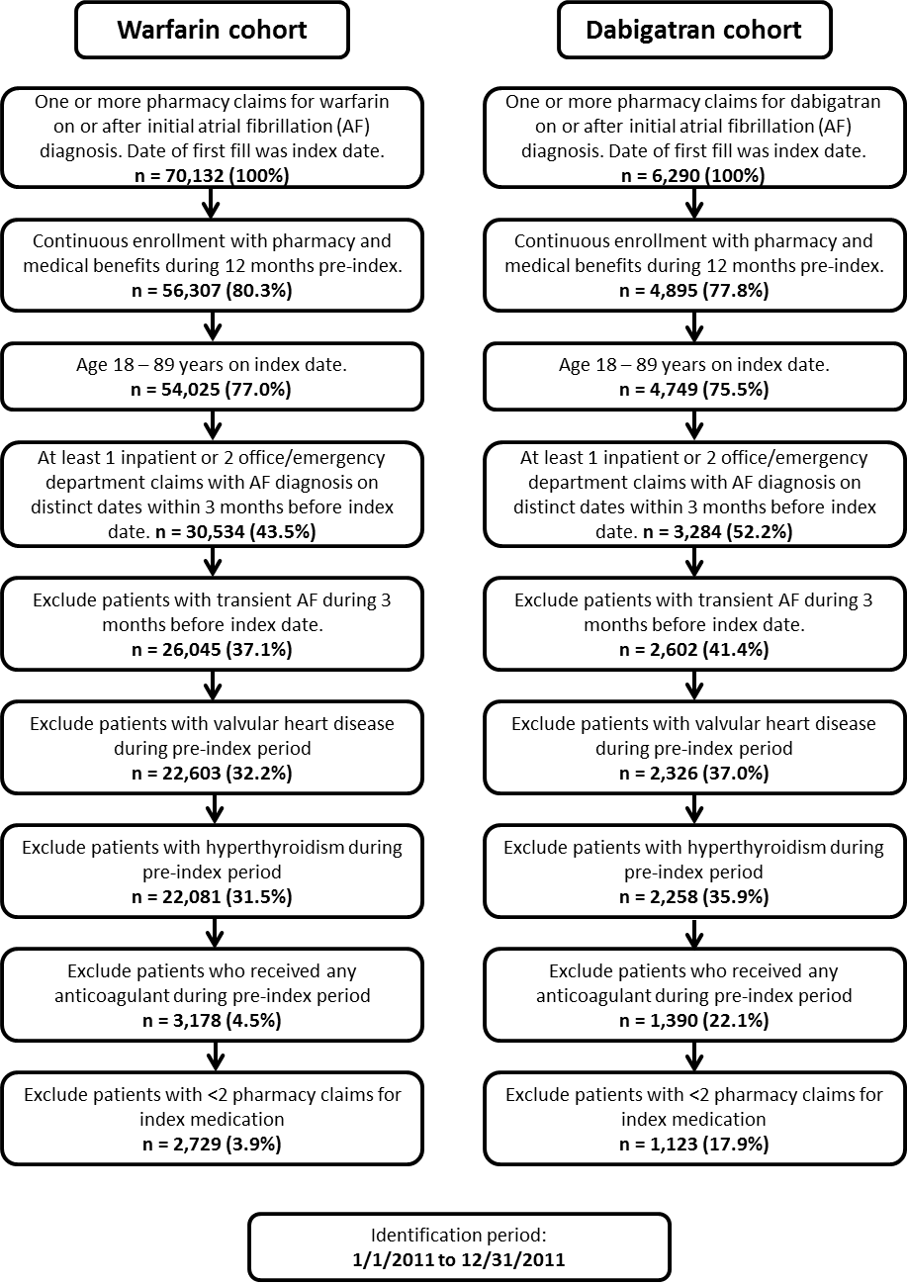

Appendix E. Post-PSM Baseline Patient Demographic Characteristics
Measure | Dabigatran cohort | Warfarin  cohort | Standardized  Differences
n | 1025 | 1025 | Before PSM | After PSM
Demographic Characteristics
Age, mean (SD) | 73.91 (±8.07) | 74.04 (±8.23) | 0.238 | 0.016
Gender = Female (vs. male), n (%) | 474 (46.2%) | 456 (44.5%) | 0.077 | 0.035
Race/Ethnicity*, n (%)
White | 881 (92.6%) | 865 (91.1%) | 0.152 | 0.044
Black | 43 (4.5%) | 57 (6.0%) | 0.092 | 0.063
Hispanic | < 10 | 15 (1.6%) | 0.057 | 0.054
Other | 16 (1.7%) | 10 (1.1%) | 0.033 | 0.052
Unknown | < 10 | < 10 | 0.292 | 0.007
Geographic Region, n (%)
Northeast | 25 (2.4%) | 28 (2.7%) | 0.010 | 0.018
Midwest | 250 (24.4%) | 252 (24.6%) | 0.144 | 0.005
South | 660 (64.4%) | 651 (63.5%) | 0.182 | 0.018
West | 90 (8.8%) | 94 (9.2%) | 0.078 | 0.014
Line of business=Medicare (vs. commercial), n (%) | 951 (92.8%) | 950 (92.7%)
Plan Type, n (%)
Medicare-HMO | 375 (36.6%) | 378 (36.9%) | 0.075 | 0.006
Medicare-PPO | 419 (40.9%) | 418 (40.8%) | 0.036 | 0.002
Medicare-FFS | 157 (15.3%) | 154 (15.0%) | 0.150 | 0.008
Commercial | 74 (7.2%) | 75 (7.3%) | 0.287 | 0.004
Estimated Household Income, n(%)
< $15,000 | 132 (12.9%) | 164 (16.0%) | 0.136 | 0.089
$15,000 - $19,999 | 42 (4.1%) | 43 (4.2%) | 0.026 | 0.005
$20,000 - $29,999 | 75 (7.3%) | 94 (9.2%) | 0.099 | 0.067
$30,000 - $39,999 | 80 (7.8%) | 92 (9.0%) | 0.061 | 0.042
$40,000 - $49,999 | 81 (7.9%) | 100 (9.8%) | 0.058 | 0.065
$50,000 - $59,999 | 106 (10.3%) | 88 (8.6%) | 0.049 | 0.060
$60,000 - $74,999 | 119 (11.6%) | 126 (12.3%) | 0.035 | 0.021
$75,000 - $99,999 | 145 (14.1%) | 152 (14.8%) | 0.063 | 0.019
$100,000 - $124,999 | 78 (7.6%) | 56 (5.5%) | 0.115 | 0.087
$125,000 - $149,999 | 47 (4.6%) | 26 (2.5%) | 0.149 | 0.111
$150,000 - $199,999 | 33 (3.2%) | 25 (2.4%) | 0.106 | 0.047
$200,000 - $249,999 | 18 (1.8%) | < 10 | 0.137 | 0.087
$250,000 - $399,999 | < 10 | < 10 | 0.046 | 0.037
$400,000 - $499,999 | < 10 | < 10 | 0.021 | 0.000
$500,000+ | < 10 | < 10 | 0.059 | 0.050
Unknown | 55 (5.4%) | 43 (4.2%) | 0.028 | 0.055
SD: Standard deviation. IQR: Interquartile range.
Note:
* Default race for Medicare members only.

Appendix F. Post-PSM Clinical and Cost Characteristics: Dabigatran Compared to Warfarin Cohort
Measure | Dabigatran cohort | Warfarin  cohort | Standardized  Differences
n | 1025 | 1025 | Before PSM | After PSM
Clinical Characteristics
Deyo Charlson Comorbidity Index, mean (SD) | 2.12 (±2.07) | 2.22 (±2.27) | 0.355 | 0.043
Deyo Charlson Comorbidity Index, median [IQR] | 2.00 [2.00] | 2.00 [2.00]
Comorbidities of interest (n%)
Cancer | 83 (8.1%) | 85 (8.3%) | 0.061 | 0.007
Rheumatoid arthritis | 21 (2.0%) | 24 (2.3%) | 0.050 | 0.020
Multiple sclerosis | 0 | < 10 | 0.027 | 0.044
Coronary artery disease | 352 (34.3%) | 362 (35.3%) | 0.089 | 0.020
Acute myocardial infarction | 28 (2.7%) | 31 (3.0%) | 0.107 | 0.018
Cardiomyopathy | 85 (8.3%) | 72 (7.0%) | 0.046 | 0.048
Ischemic stroke | 119 (11.6%) | 122 (11.9%) | 0.066 | 0.009
Transient ischemic attack | 79 (7.7%) | 74 (7.2%) | 0.024 | 0.019
Congestive heart failure | 253 (24.7%) | 250 (24.4%) | 0.268 | 0.007
Left ventricular heart failure | 13 (1.3%) | 15 (1.5%) | 0.039 | 0.017
Atrial flutter | 136 (13.3%) | 129 (12.6%) | 0.066 | 0.020
Hypertension | 869 (84.8%) | 866 (84.5%) | 0.059 | 0.008
Peripheral artery disease | 131 (12.8%) | 135 (13.2%) | 0.121 | 0.012
Liver disease | 26 (2.5%) | 20 (2.0%) | 0.053 | 0.040
Renal disease | 249 (24.3%) | 266 (26.0%) | 0.286 | 0.038
Chronic obstructive pulmonary disease/emphysema | 204 (19.9%) | 209 (20.4%) | 0.190 | 0.012
Diabetes | 325 (31.7%) | 328 (32.0%) | 0.176 | 0.006
Peptic ulcer/gastroesophageal reflux disease (GERD) | 149 (14.5%) | 154 (15.0%) | 0.058 | 0.014
Venous thromboembolism | < 10 | 37 (3.6%) | 0.272 | 0.203
Hyperlipidemia | 593 (57.9%) | 606 (59.1%) | 0.027 | 0.026
HIV infection | 0 | < 10 | 0.047 | 0.044
Bone marrow disease (thrombocytopenia, chronic anemia, myelofibrosis) | 39 (3.8%) | 45 (4.4%) | 0.142 | 0.030
Coagulopathy (hemophilia, Von Willebrand disease) | < 10 | 16 (1.6%) | 0.140 | 0.133
Dyspepsia | < 10 | < 10 | 0.026 | 0.024
Other Medication Use (n%)
Beta blockers | 746 (72.8%) | 739 (72.1%) | 0.023 | 0.015
Calcium channel blockers | 458 (44.7%) | 463 (45.2%) | 0.097 | 0.010
Diuretics | 463 (45.2%) | 453 (44.2%) | 0.215 | 0.020
Other antihypertensives (i.e. ACE inhibitors, combinations) | 677 (66.0%) | 694 (67.7%) | 0.060 | 0.035
Antihyperlipidemics | 609 (59.4%) | 605 (59.0%) | 0.014 | 0.008
Corticosteroids | 205 (20.0%) | 194 (18.9%) | 0.088 | 0.027
Antidiabetics | 263 (25.7%) | 265 (25.9%) | 0.124 | 0.004
Antiarrhythmics | 244 (23.8%) | 248 (24.2%) | 0.182 | 0.009
Ketoconazole | 19 (1.9%) | 18 (1.8%) | 0.007 | 0.007
Antiplatelets (e.g., dipyridamole, aspirin, etc.) | 161 (15.7%) | 163 (15.9%) | 0.116 | 0.005
Month of index exposure (n%)
January | 101 (9.9%) | 133 (13.0%) | 0.124 | 0.098
February | 88 (8.6%) | 132 (12.9%) | 0.091 | 0.139
March | 87 (8.5%) | 114 (11.1%) | 0.106 | 0.089
April | 88 (8.6%) | 107 (10.4%) | 0.040 | 0.063
May | 95 (9.3%) | 99 (9.7%) | 0.009 | 0.013
June | 106 (10.3%) | 67 (6.5%) | 0.103 | 0.137
July | 84 (8.2%) | 60 (5.9%) | 0.093 | 0.092
August | 71 (6.9%) | 65 (6.3%) | 0.022 | 0.024
September | 78 (7.6%) | 72 (7.0%) | 0.038 | 0.022
October | 86 (8.4%) | 54 (5.3%) | 0.099 | 0.124
November | 77 (7.5%) | 53 (5.2%) | 0.062 | 0.096
Number of unique medication classes, mean (SD) | 11.42 (±5.88) | 11.65 (±5.53) | 0.196 | 0.039
Number of unique medication classes, median [IQR] | 11.00 [8.00] | 11.00 [7.00]
Number of prescriptions for cardiovascular medications, mean (SD) | 9.93 (±7.60) | 9.95 (±7.38) | 0.058 | 0.003
Number of prescriptions for cardiovascular medications, median [IQR] | 9.00 [10.00] | 9.00 [9.00]
Days from AF to index, mean (SD) | 20.66 (±22.86) | 20.57 (±23.62) | 0.008 | 0.004
Days from AF to index, median [IQR] | 10.00 [30.00] | 8.00 [28.00]
Baseline stroke risk
CHADS₂ stroke risk score, mean (SD) | 2.20 (±1.25) | 2.26 (±1.26) | 0.320 | 0.047
CHADS₂ stroke risk score, median [IQR] | 2.00 [2.00] | 2.00 [2.00]
CHA₂DS₂-VASc stroke risk score, mean (SD) | 3.75 (±1.52) | 3.80 (±1.56) | 0.340 | 0.029
CHA₂DS₂-VASc stroke risk score, median [IQR] | 4.00 [2.00] | 4.00 [2.00]
Baseline bleeding risk: HEMORR₂HAGES score, mean (SD) | 2.37 (±1.47) | 2.43 (±1.51) | 0.355 | 0.039
Baseline bleeding risk: HEMORR₂HAGES score, median [IQR] | 2.00 [2.00] | 2.00 [2.00]
Index prescriber specialty (n%)
Family practice | 187 (18.2%) | 173 (16.9%) | 0.193 | 0.036
Internal medicine | 480 (46.8%) | 497 (48.5%) | 0.094 | 0.033
Cardiology | 161 (15.7%) | 170 (16.6%) | 0.314 | 0.024
Neurology | < 10 | < 10 | 0.013 | 0.040
Emergency medicine | 12 (1.2%) | 10 (1.0%) | 0.071 | 0.019
Pulmonary medicine | 0 | 0 | 0.038 | .
Hematology | 0 | < 10 | 0.047 | 0.044
Geriatrics | < 10 | < 10 | 0.033 | 0.000
Gastroenterology | < 10 | 0 | 0.006 | 0.044
Surgery | < 10 | < 10 | 0.110 | 0.000
Other | 144 (14.0%) | 140 (13.7%) | 0.137 | 0.011
Pre-index total medical cost, mean (SD) | 13,681 (±18,674) | 15,991 (±22,979) | 0.291 | 0.110
Pre-index total medical cost, median [IQR] | 8,405 [11,732] | 9,124 [13,413]
Pre-index total pharmacy cost, mean (SD) | 2,498 (±2,847) | 2,287 (±3,797) | 0.110 | 0.063
Pre-index total pharmacy cost, median [IQR] | 1,716 [2,818] | 1,517 [2,529]
Pre-index out-of-pocket medical cost, mean (SD) | 1,359 (±1,569) | 1,480 (±1,807) | 0.190 | 0.071
Pre-index out-of-pocket medical cost, median [IQR] | 873 [1,388] | 877 [1,583]
Pre-index out-of-pocket pharmacy cost, mean (SD) | 664 (±879) | 590 (±785) | 0.160 | 0.088
Pre-index out-of-pocket pharmacy cost, median [IQR] | 362 [737] | 354 [638]
SD: Standard deviation. IQR: Interquartile range.
Note:
All cost amounts were inflation-adjusted to 2015 United States Dollars.

Appendix G. Distributions of Monthly OOP Costs for Dabigatran and Warfarin
Distribution of Monthly OOP Costs for Dabigatran
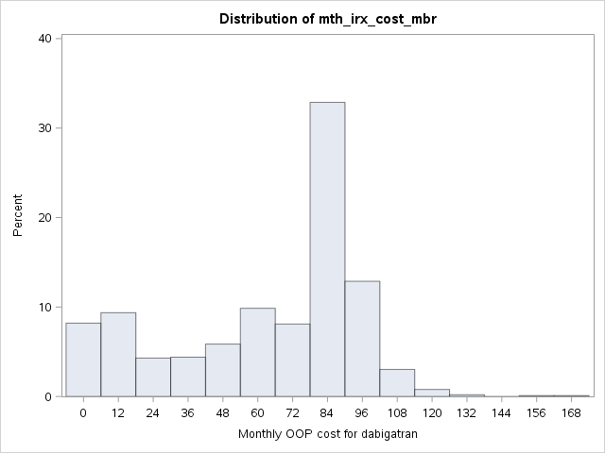
Level | Quantile
100% Max | 173.84201
99% | 114.41976
95% | 100.35657
90% | 94.69632
75% Q3 | 89.28
50% Median | 77.856
25% Q1 | 35.75006
10% | 7.00959
5% | 3.18755
1% | 0
0% Min | 0

Distribution of Monthly OOP Costs for Warfarin
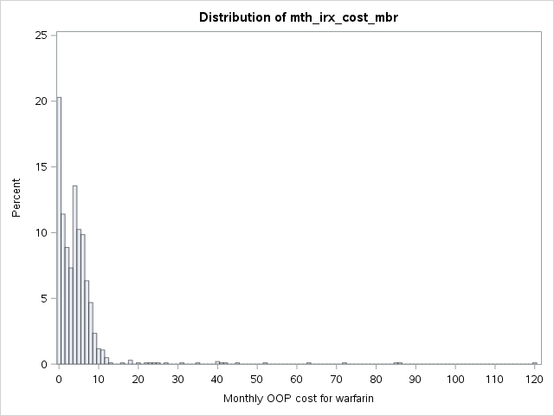
Level | Quantile
100% Max | 120.451482
99% | 39.737571
95% | 9.540451
90% | 7.812
75% Q3 | 5.812165
50% Median | 3.7554
25% Q1 | 0.950749
10% | 0
5% | 0
1% | 0
0% Min | 0

Appendix F. Association of Non-Persistence with Treatment Cohort (Dabigatran vs. Warfarin), Adjusting for Covariates
Parameter | Estimate | Standard error | Chi Sq | P-value | Hazard ratio | Lower 95% CI | Upper 95% CI
Cohort (Dabigatran vs. Warfarin, 1=Dabigatran) | -0.073 | 0.098 | 0.559 | 0.455 | 0.930 | 0.766 | 1.123
Monthly pharmacy OOP cost for index medication | 0.005 | 0.001 | 15.434 | <0.0001 | 1.005 | 1.002 | 1.007
Age | -0.003 | 0.006 | 0.267 | 0.606 | 0.997 | 0.986 | 1.008
Gender: female vs. male | 0.061 | 0.078 | 0.610 | 0.435 | 1.062 | 0.913 | 1.237
Race/ethnicity: Unknown vs. White | 0.360 | 0.512 | 0.494 | 0.482 | 1.433 | 0.438 | 3.435
Race/ethnicity: Other vs. White | 0.072 | 0.265 | 0.074 | 0.786 | 1.075 | 0.611 | 1.742
Race/ethnicity: Hispanics vs. White | 0.314 | 0.254 | 1.524 | 0.217 | 1.368 | 0.801 | 2.181
Race/ethnicity: Black vs. White | 0.032 | 0.142 | 0.050 | 0.824 | 1.032 | 0.773 | 1.350
Region: West vs. Northeast | 0.073 | 0.203 | 0.130 | 0.718 | 1.076 | 0.731 | 1.622
Region: Southwest vs. Northeast | -0.046 | 0.183 | 0.065 | 0.799 | 0.955 | 0.678 | 1.390
Region: Midwest vs. Northeast | -0.238 | 0.188 | 1.599 | 0.206 | 0.788 | 0.553 | 1.159
Plan type: commercial vs. Medicare HMO | -0.039 | 0.524 | 0.006 | 0.941 | 0.962 | 0.389 | 3.205
Plan type: Medicare FFS vs. Medicare HMO | -0.111 | 0.095 | 1.371 | 0.242 | 0.895 | 0.741 | 1.076
Plan type: Medicare PPO vs. Medicare HMO | 0.013 | 0.071 | 0.032 | 0.858 | 1.013 | 0.881 | 1.164
Household income: unknown vs. <$15,000 | 0.102 | 0.154 | 0.444 | 0.505 | 1.108 | 0.814 | 1.489
Household income: >$100,000 vs. <$15,000 | 0.127 | 0.112 | 1.268 | 0.260 | 1.135 | 0.911 | 1.416
Household income: $50,000 - $100,000 vs. <$15,000 | 0.008 | 0.097 | 0.006 | 0.937 | 1.008 | 0.835 | 1.221
Household income: $15,000 - $50,000 vs. <$15,000 | 0.077 | 0.098 | 0.625 | 0.429 | 1.080 | 0.894 | 1.310
Deyo-Charlson comorbidity score | 0.023 | 0.024 | 0.908 | 0.341 | 1.023 | 0.975 | 1.073
CHA₂DS₂VASc stroke risk score | -0.050 | 0.050 | 1.015 | 0.314 | 0.951 | 0.863 | 1.048
HEMORR₂HAGES bleed risk score | 0.031 | 0.030 | 1.029 | 0.311 | 1.031 | 0.971 | 1.094
Cancer | 0.099 | 0.118 | 0.705 | 0.401 | 1.104 | 0.872 | 1.387
Rheumatoid arthritis | -0.292 | 0.218 | 1.788 | 0.181 | 0.747 | 0.474 | 1.119
Coronary artery disease | -0.033 | 0.069 | 0.228 | 0.633 | 0.967 | 0.844 | 1.108
Acute myocardial infarction | 0.137 | 0.181 | 0.575 | 0.448 | 1.147 | 0.793 | 1.613
Cardiomyopathy | -0.078 | 0.118 | 0.435 | 0.510 | 0.925 | 0.731 | 1.160
Ischemic stroke | -0.090 | 0.128 | 0.499 | 0.480 | 0.914 | 0.711 | 1.172
Transient ischemic attack | 0.104 | 0.128 | 0.658 | 0.417 | 1.110 | 0.859 | 1.422
Congestive heart failure | 0.185 | 0.093 | 3.959 | 0.047 | 1.203 | 1.002 | 1.442
Left ventricular heart failure | -0.252 | 0.272 | 0.859 | 0.354 | 0.777 | 0.438 | 1.278
Atrial flutter | 0.171 | 0.087 | 3.867 | 0.049 | 1.187 | 0.998 | 1.404
Hypertension | 0.127 | 0.104 | 1.474 | 0.225 | 1.135 | 0.927 | 1.395
Peripheral artery disease | 0.047 | 0.098 | 0.228 | 0.633 | 1.048 | 0.862 | 1.266
Liver disease | -0.194 | 0.210 | 0.852 | 0.356 | 0.824 | 0.534 | 1.220
Renal disease | -0.010 | 0.082 | 0.014 | 0.908 | 0.991 | 0.843 | 1.162
Chronic obstructive pulmonary disease/emphysema | 0.020 | 0.082 | 0.059 | 0.808 | 1.020 | 0.868 | 1.196
Diabetes | -0.008 | 0.119 | 0.005 | 0.944 | 0.992 | 0.783 | 1.249
Peptic ulcer/gastroesophageal reflux disease (GERD) | 0.057 | 0.084 | 0.460 | 0.498 | 1.059 | 0.896 | 1.244
Venous thromboembolism | -0.277 | 0.220 | 1.589 | 0.208 | 0.758 | 0.480 | 1.141
Hyperlipidemia | -0.135 | 0.073 | 3.443 | 0.064 | 0.874 | 0.759 | 1.008
Bone marrow disease (thrombocytopenia, chronic anemia, myelofibrosis) | 0.176 | 0.152 | 1.347 | 0.246 | 1.193 | 0.878 | 1.593
Coagulopathy (hemophilia, Von Willebrand disease) | -0.027 | 0.317 | 0.007 | 0.933 | 0.974 | 0.493 | 1.728
Dyspepsia | -0.260 | 0.367 | 0.503 | 0.478 | 0.771 | 0.345 | 1.481
Beta blockers | -0.006 | 0.070 | 0.007 | 0.933 | 0.994 | 0.867 | 1.142
Calcium channel blockers | -0.002 | 0.062 | 0.001 | 0.980 | 0.998 | 0.884 | 1.128
Diuretics | 0.022 | 0.066 | 0.106 | 0.745 | 1.022 | 0.897 | 1.164
Other antihypertensives (i.e. ACE inhibitors, combinations) | 0.081 | 0.070 | 1.343 | 0.247 | 1.084 | 0.946 | 1.245
Antihyperlipidemics | -0.057 | 0.075 | 0.580 | 0.446 | 0.945 | 0.816 | 1.094
Corticosteroids | 0.054 | 0.078 | 0.482 | 0.488 | 1.056 | 0.904 | 1.229
Antidiabetics | 0.003 | 0.116 | 0.001 | 0.982 | 1.003 | 0.801 | 1.260
Antiarrhythmics | 0.288 | 0.070 | 17.111 | <0.0001 | 1.334 | 1.163 | 1.528
Ketoconazole | -0.045 | 0.225 | 0.041 | 0.841 | 0.956 | 0.597 | 1.445
Antiplatelets (e.g., dipyridamole, aspirin, etc.) | 0.121 | 0.088 | 1.889 | 0.169 | 1.129 | 0.948 | 1.340
Index month: December vs. January | -0.182 | 0.154 | 1.391 | 0.238 | 0.834 | 0.614 | 1.124
Index month: November vs. January | -0.162 | 0.155 | 1.081 | 0.299 | 0.851 | 0.624 | 1.149
Index month: October vs. January | 0.010 | 0.147 | 0.005 | 0.944 | 1.010 | 0.756 | 1.344
Index month: September vs. January | 0.009 | 0.141 | 0.004 | 0.948 | 1.009 | 0.763 | 1.329
Index month: August vs. January | 0.175 | 0.143 | 1.489 | 0.222 | 1.191 | 0.897 | 1.575
Index month: July vs. January | 0.096 | 0.141 | 0.458 | 0.499 | 1.100 | 0.832 | 1.448
Index month: June vs. January | 0.141 | 0.134 | 1.112 | 0.292 | 1.151 | 0.885 | 1.496
Index month: May vs. January | 0.076 | 0.130 | 0.338 | 0.561 | 1.079 | 0.835 | 1.393
Index month: April vs. January | 0.017 | 0.134 | 0.016 | 0.900 | 1.017 | 0.781 | 1.323
Index month: March vs. January | -0.048 | 0.132 | 0.132 | 0.717 | 0.953 | 0.734 | 1.235
Index month: February vs. January | 0.136 | 0.127 | 1.157 | 0.282 | 1.146 | 0.894 | 1.470
Days from AF to index | 0.001 | 0.001 | 0.362 | 0.548 | 1.001 | 0.998 | 1.003
Prescribing physician specialty: Other vs. family practice | -0.004 | 0.099 | 0.002 | 0.968 | 0.996 | 0.820 | 1.211
Prescribing physician specialty: Cardiology vs. family practice | -0.141 | 0.105 | 1.815 | 0.178 | 0.868 | 0.707 | 1.066
Prescribing physician specialty: Internal medicine vs. family practice | -0.078 | 0.084 | 0.863 | 0.353 | 0.925 | 0.787 | 1.092
Number of unique medication classes | 0.015 | 0.007 | 4.628 | 0.032 | 1.015 | 1.001 | 1.029
Number of prescriptions for cardiovascular medications | -0.020 | 0.005 | 16.094 | <0.0001 | 0.980 | 0.971 | 0.990

