Supplementary materials
Figure S1. Schematic representation of the observation period*.
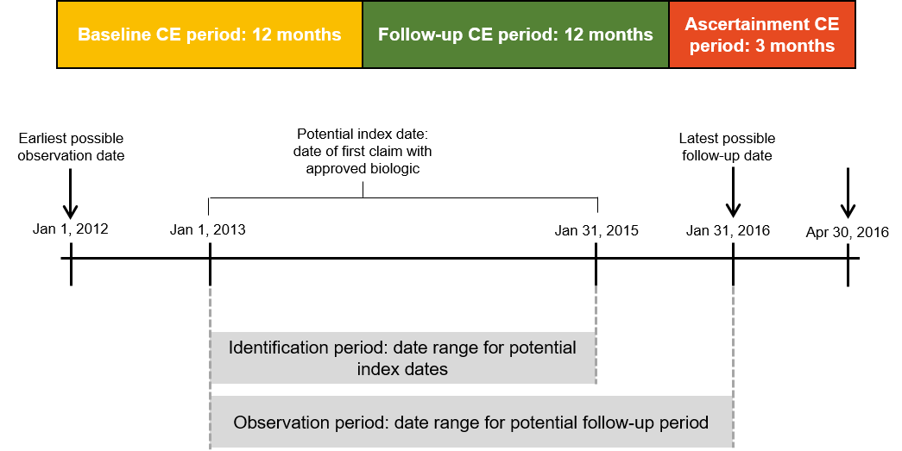

*Patients were required to have ≥ 2 non−rule-out diagnoses for ankylosing spondylitis during the study. The 2 claims had to be ≥ 30 days apart, and the first claim had to be on the index date or during the baseline period.

Table S1. Adherence and duration of persistence.
 | Total  (N = 426) | TNFi-SC |  |  |  | TNFi-IV
 | Total  (N = 426) | Adalimumab  (n = 122) | Certolizumab pegol  (n = 12) | Etanercept  (n = 192) | Golimumab  (n = 50) | Infliximab  (n = 50)
Duration of persistence, days
Mean (SD) | 236 (131) | 243 (132) | 208 (143) | 192 (131) | 248 (132) | 249 (127)
Median (IQR) | 274 (105, 365) | 289 (100, 365) | 199 (64, 365) | 234 (405, 365) | 343 (127, 365) | 294 (128, 365)
Proportion of days covered*
Mean (SD) | 0.56 (0.29) | 0.58 (0.29) | 0.47 (0.32) | 0.55 (0.30) | 0.56 (0.29) | 0.60 (0.29)
Median (IQR) | 0.60 (0.30, 0.84) | 0.65 (0.31, 0.85) | 0.45 (0.15, 0.77) | 0.59 (0.30, 0.84) | 0.61 (0.30, 0.85) | 0.68 (0.27, 0.84)
*Proportion of days covered was defined as the number of days covered by prescription claims for the index TNFi divided by 365 (follow-up period).
IV: Intravenous; SC: Subcutaneous; TNFi: Tumor necrosis factor inhibitor.

Table S2. Inflammatory conditions among patients during the 12 months before and 12 months after the index date.
Inflammatory conditions, n (%)* | Total  (N = 426) | TNFi-SC |  |  |  | TNFi-IV
Inflammatory conditions, n (%)* | Total  (N = 426) | Adalimumab  (n = 122) | Certolizumab Pegol  (n = 12) | Etanercept  (n = 192) | Golimumab  (n = 50) | Infliximab  (n = 50)
Ulcerative colitis | 26 (6.1) | 8 (6.6) | 2 (16.7) | 6 (3.1) | 4 (8.0) | 6 (12.0)
Crohn disease | 23 (5.4) | 6 (4.9) | 6 (50.0) | 5 (2.6) | 0 (0.0) | 6 (12.0)
Psoriasis | 13 (3.0) | 5 (4.1) | 2 (16.7) | 1 (0.5) | 3 (6.0) | 2 (4.0)
*Inflammatory conditions were defined with at least one claim anywhere in the 12 months before and after the index date.
IV: Intravenous; SC: Subcutaneous; TNFi: Tumor necrosis factor inhibitor.

Figure S2. Dose escalation of the index TNFi in the 12-month follow-up period.
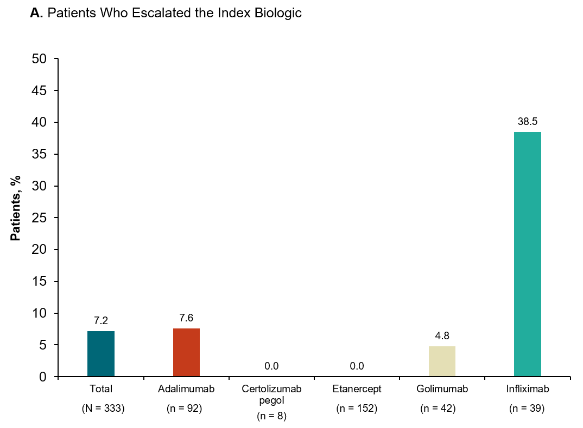
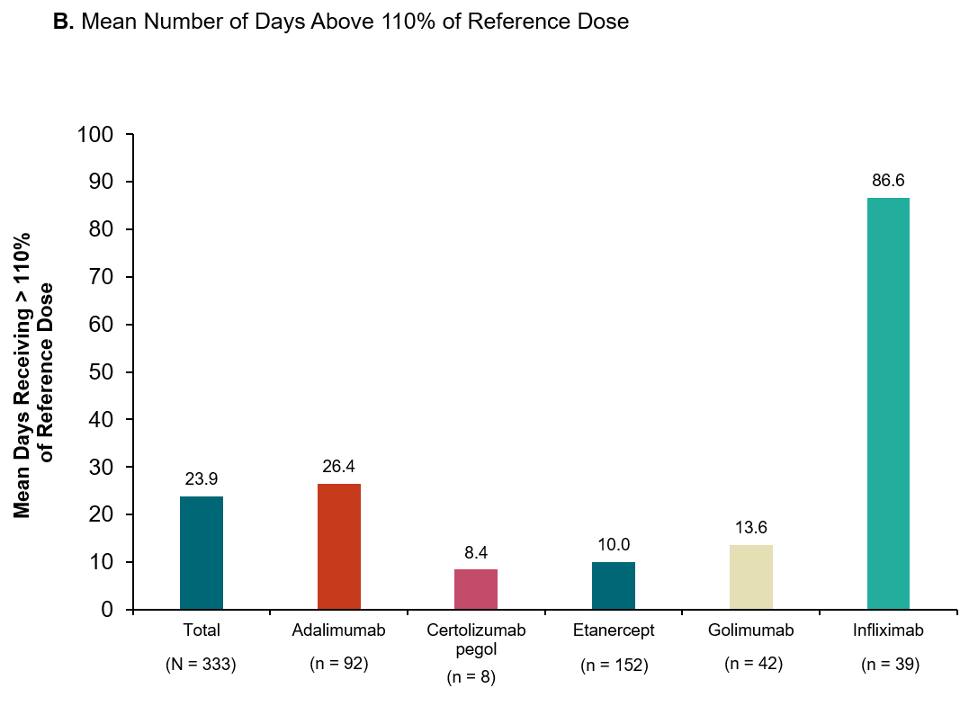
TNFi: Tumor necrosis factor inhibitor.

