Appendix Table 1. Clinical characteristics at baseline and before therapy initiation.
 |  | 1L*  (n=282) | 1L**  (n=282) | 2L*  (n=38) |  | 2L***  (n=38)
Characteristic |  | 1L*  (n=282)
CCI score:
mean |  | 1 | 2.3 |  | 1 | 2.7
SD |  | 1.1 | 0.9 |  | 1.1 | 0.9
median |  | 0 | 2 |  | 1 | 2
CCI score distribution: (%)
0 |  | 50.4 | 2.8 |  | 44.7 | 0.0
1 |  | 11.7 | 0.7 |  | 15.8 | 0.0
2 |  | 29.4 | 68.1 |  | 34.2 | 52.6
3+ |  | 8.5 | 28.4 |  | 5.3 | 47.4
Frequent (>10%) relevant comorbidities of interest: (%)
Abdominal pain |  | 13.5 | 15.2 |  | 10.5 | 10.5
Adenopathy |  | 5.7 | 9.6 |  | 2.6 | 10.5
Anemia |  | 31.2 | 39.7 |  | 18.4 | 42.1
Aplastic anemia |  | 35.8 | 49.6 |  | 18.4 | 39.5
Diabetes |  | 11.0 | 10.6 |  | 13.2 | 13.2
Fatigue |  | 19.5 | 21.3 |  | 15.8 | 13.2
Hypertension |  | 26.2 | 30.9 |  | 28.9 | 28.9
Mild liver disease |  | 2.8 | 6.4 |  | 0.0 | 15.8
AMI |  | 7.1 | 7.8 |  | 7.9 | 13.2
Splenomegaly |  | 20.9 | 37.2 |  | 18.4 | 34.2
All-cause healthcare costs:
mean |  | $6,635 | $16,018 |  | $4,370 | $35,623
SD |  | $7,246 | $17,172 |  | $4,429 | $32,989
median |  | $4,627 | $10,173 |  | $2,590 | $30,205
*Measured in the 6-months prior to the diagnosis date.
**Measured in the 6-months prior to 1L therapy initiation.
***Measured in the 6-months prior to 2L therapy initiation.
1L: First line; 2L: Second line; AMI: Acute myocardial infarction; CCI: Charlson Comorbidity Index; Hem/Onc: Hematology/Oncology; Primary: General Practitioner/Family Medicine/Internal Medicine.

Appendix Figure 1. 2L treatment pathways for 1L cladribine patients by year of 1L cladribine initiation.

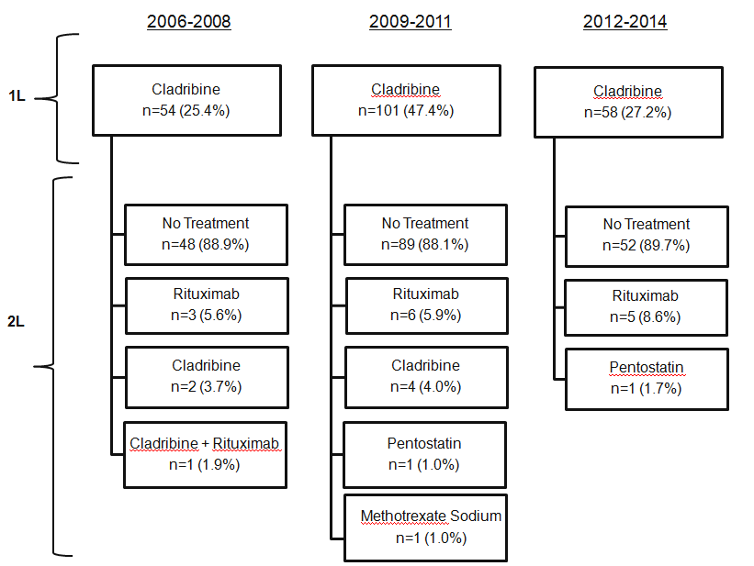

Appendix Table 2. Line of therapy characteristics.
 | All Patients
 | (N=749)
Measure | Mean | SD | Median
Proportion of patients initiating 1L therapy (n,%) | 282 | 37.7%
Time from index date to 1L therapy initiation (months) | 4.4 | 9.8 | 1
Time from 1L therapy initiation to end of follow-up (months) | 29.5 | 21.0 | 23
1L therapy duration (days) | 34.1 | 104.4 | 5
1L cladribine (n,%) | 213 | 75.5%
1L cladribine duration (days) | 7.3 | 16.2 | 5
1L cladribine administration days | 3.4 | 3.0 | 2
Proportion of patients initiating 2L therapy (n,%) | 38 | 5.1%
Time from index date to 2L therapy initiation (months) | 16.0 | 16.7 | 8.0
Time from 2L therapy initiation to end of follow-up (months) | 23.9 | 19.6 | 17
2L therapy duration (days) | 53.7 | 70.9 | 28
2L rituximab (n,%) | 213 | 52.6%
2L rituximab duration (days) | 69.4 | 78.0 | 50
2L rituximab administration days | 4.9 | 2.1 | 4
1L: First line; 2L: Second line.

