Supplementary Appendix

Supplementary Figures

Figure 1 - Glycemic control after 6 months using glargine analog, by age group.

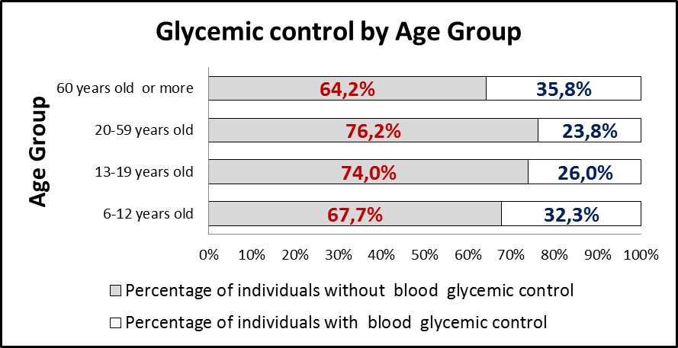

Supplementary Tables

Table 1 – Inclusion criteria to dispensing program of glargine analog in Clinical Protocol and Therapeutic Guidelines (1).

1. The diagnosis of diabetes mellitus type 1 and LADA should be proven through detailed medical reports and supplementary examinations: fasting glucose and / or random, confirmed by a second dose and glycated hemoglobin. Other examinations may be required where there continue to be doubts as to the correct classification applicable to the patient.
2. It is necessary to document the persistence of poor glycemic control and the incidence of severe hypoglycemia without warning signs. The evidence of poor glycemic control will be made by the demonstration of laboratory tests (glycated hemoglobin and blood glucose levels) recorded 2 times at intervals of four months between tests. For the purposes specified in this protocol, it is understood that poor glycemic control is the persistence of glycohemoglobin with more than 2 percentage points above the normal test upper limit.
3. Patients who suffer from severe hypoglycemia (less than 50 mg / dl) for 2 or 3 proven episodes by laboratory examination and / or hospital care report this condition in at least two separate occasions in the past six months, they may be included in the same program without the confirmation of the occurrence of persistent hyperglycemia, as defined in item 2.
4. Be older than 6 years.
5. Patients who have been administered glargine analog for more than a year, which have not yet been included in the glargine dispensing program, and to monitor glycemic control - should have record of severe hypoglycemic episodes as described in items 2 and 3.

Table 2 - Patients characteristics (N = 580). Minas Gerais, Brazil

Variable |  | N | (%)
Sex | Male | 290 | 50
 | Female | 290 | 50
Ethnicity | White | 196 | 33.8
 | Black | 15 | 2.6
 | Brown | 66 | 11.4
 | Uninformed | 303 | 52.2
Age | 06-12 | 65 | 11.2
 | 13-19 | 96 | 16.6
 | 20-59 | 366 | 63.1
 | >=60 | 53 | 9.1
Report of comorbidities | Yes | 122 | 21
Report of comorbidities | No | 458 | 79.0

Table 3 - Descriptive statistics of patients included in the study.

Variable | Average | Standard Deviation | Median | Minimum | Maximum
Age (years) | 33.04 | 17.357 | 31.00 | 6 | 75
Age at diagnosis (years) | 17.50 | 13.185 | 13.50 | 0 | 65
Diagnosis time (years) | 14.80 | 12.776 | 12.00 | 1 | 57

Table 4 - Characteristics of the treatment used (N = 580). Minas Gerais, Brazil.

Variável |  | N | (%)
Type of Treatment | Conventional | 150 | 25.9
 | Intensive | 287 | 49.5
 | Uninformed | 143 | 24.7
Carbohydrates Counting | Yes | 144 | 24.8
 | No | 177 | 30.5
 | Uninformed | 259 | 44.7
Insulin type of fast/ultrafast acting | Regular | 180 | 31.0
Insulin type of fast/ultrafast acting | Short-acting analog | 144 | 24.8
 | Uninformed | 256 | 44.1
 | Total | 580 | 100.0
Frequency | once a day | 537 | 92.6
Frequency | twice a day | 43 | 7.4
 | 3 times a day | 580 | 100.0

Table 5 - Dose Analysis of analog glargine in different age groups.

Variable | N | Average | Standard Deviation | Minimum | Maximum | p-Value
Dosage (UI) |  |  |  |  |  | 0,000*
6 a 12 | 65 | 19.18 | 10.927 | 6 | 58 | 0,000*
13 a 19 | 96 | 33.53 | 13.643 | 2 | 60 | 0,000*
20 a 59 | 366 | 37.24 | 14.925 | 6 | 120 | 0,000*
≥60 | 53 | 35.53 | 13.584 | 10 | 80 | 0,000*
Note: * Statistically significant difference. Post hoc analysis was performed using the Tukey test.

REFERENCES
1. MINAS GERAIS. Secretaria de Estado de Saúde de Minas Gerais. Resolução SES-MG Nº 2359 de 17 de junho de 2010 - Dispõe sobre o Protocolo Clínico e Diretrizes Terapêuticas para a utilização de análogo Glargina em portadores de Diabetes Mellitus Tipo 1 (DM1). Diário da Imprensa Oficial de Minas Gerais Poder Executivo, Belo Horizonte. 2010;1–27.

